CVWO 2019/2020

Name: Low Jie Feng Matriculation Number: A0201747J

# Write-up on Accomplishments

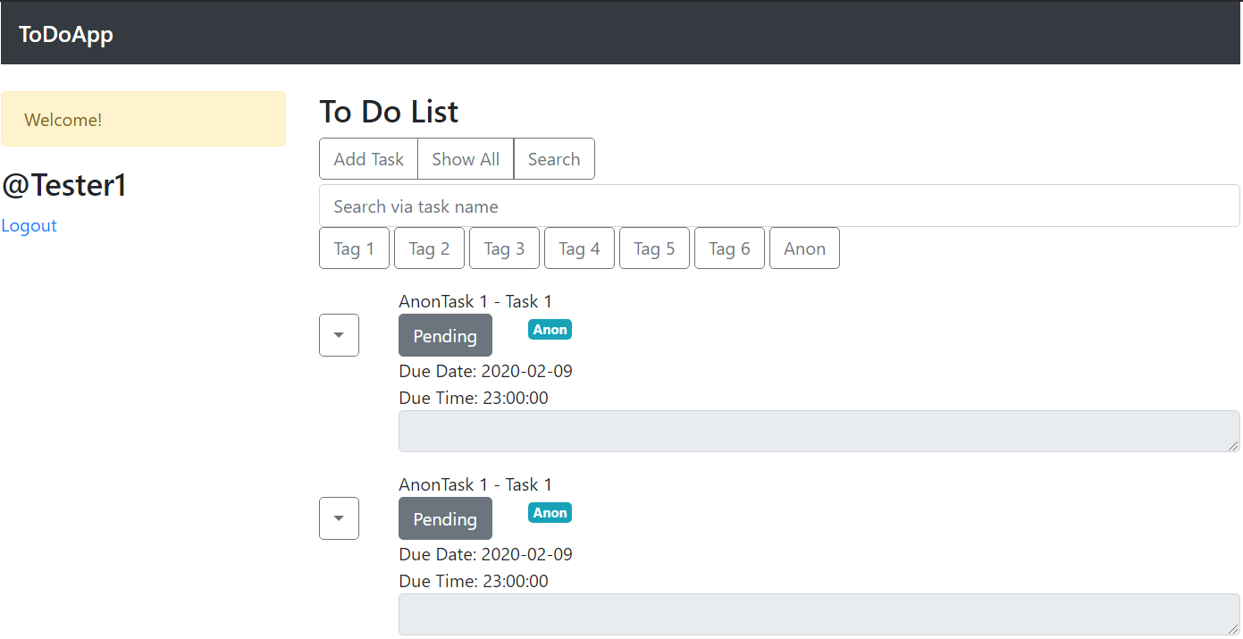

This is a to-do app written using Ruby on Rails as the backend and React as the frontend (as required). In addition, the site is hosted on Heroku, and the frontend is mostly written in Typescript, using Redux to manage some states across the React components (as recommended). Several JavaScript libraries were used to simplify the process – namely Bootstrap and React-Bootstrap as the styling library, as well as Formik and Yup for the various forms.

The application supports the basic CRUD operations on tasks. It allows users to use the site without having to login, but also permits them to save their tasks under their own username (the function to configure user details was not implemented).

Tasks can be flagged as completed using the  button

The tagging system allows users to add tags when a task is being created or updated. Searching through the tasks can be done by searching the task’s name, or by using the consolidated tag buttons.

Since it is my first time working with Ruby on Rails and the whole suite of JavaScript tools, there are some major areas I would like to improve on. Firstly, the data flow from the backend to the frontend should be more consistent. Ideally, it should be compliant with the JSON API specifications. Secondly, I think better planning could be done with Typescript and with maintaining the types involved.

# User Manual

## Adding a Task

|  |  |
| --- | --- |
|  | 1. Click on Add Task 2. Fill in task details and tags desired    * Task name is a required field 3. To save, press New Task |

## Editing and Deleting a Task

|  |  |
| --- | --- |
|  | 1. Click on Show All 2. Click on 3. Press Edit or Delete |

## Editing and Deleting a Task

|  |  |
| --- | --- |
|  | The form is the same as the one for adding a new task.  Press Update Task to save the changes. |

## Searching for a Task

|  |  |
| --- | --- |
|  | 1. Click on Search 2. Either click on the desired tag to search for or fill in the task name to search by |

## Registering and Logging In

|  |  |  |
| --- | --- | --- |
|  |  | 1. Press Register 2. Fill in the registration form  * Username must not have been taken * Passwords must match  1. Click Register 2. Then, Press Login 3. Fill in the details 4. Click Login |

Note that any tasks created while anonymous will be added to the user on login.